**Assignment 2**

**Name: Ayesha Siddiqua**

**Registration No: FA20-BCS-072**

**Subject: Mobile Application Development**

**Submitted To: Mr. Muhammad Kamran**

**Question No 1:**

**JavaScript Array Functions**

1. **push():** This function adds one or more elements to the end of an array and returns the new length of the array.

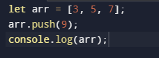

**Output:**



1. **splice():** This function can add or remove elements from an array at any position.

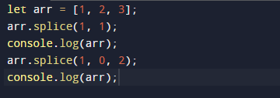

**Output:**



1. **slice():** This function returns a new array containing a portion of an existing array.

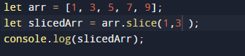

**Output:**



1. **concat():** This function is used to concatenate two or more arrays and return a new array.

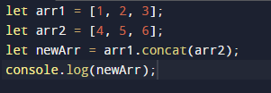

**Output:**



1. **filter():** This function is used to create a new array with all elements that pass a test implemented by the provided function.

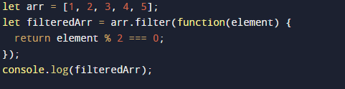

**Output:**



1. **forEach():** This function is used to execute a provided function once for each array element.

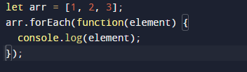

**Output:**

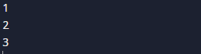

1. **map():** This function is used to create a new array with the results of calling a provided function on every element in the original array.

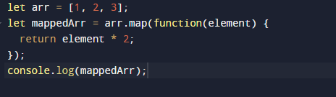

**Output:**



**Question No 2:**

**JavaScript String Functions**

1. **length:** This property returns the length of a string.



**Output:**



1. **slice():** This function returns a new string containing a portion of an existing string.

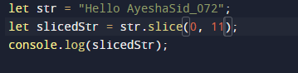

**Output:**



**3.** **substr():** This function returns a portion of a string starting from a specified index and for a specified number of characters.

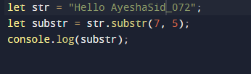

**Output:**



**4.lastIndexOf():** This function returns the index of the last occurrence of a specified substring in a string.

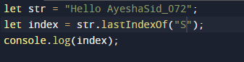

**Output:**



**5.** **includes():** This function determines whether a string contains a specified substring. It returns true if the substring is found and false otherwise.

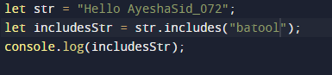

**Output:**



**6.** **toLowerCase():** This function converts all characters in a string to lowercase.

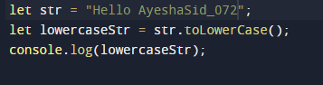

**Output:**



1. **toUpperCase():** This function converts all characters in a string to uppercase.

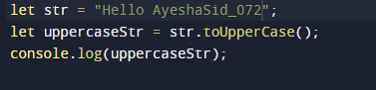

**Output:**



**Question No 3:**

**Make Chess Board using Flex**

**Code:**

import React from 'react';

import { View, StyleSheet } from 'react-native';

const Board = () => {

const board = [];

for (let i = 0; i < 8; i++) {

const row = [];

for (let j = 0; j < 8; j++) {

const color = (i + j) % 2 === 0 ? '#e6e6e6' : 'black';

row.push(

<View key={`${i}-${j}`} style={[styles.cell, { backgroundColor: color }]} />

);

}

board.push(

<View key={i} style={styles.row}>

{row}

</View>

);

}

return <View style={styles.board}>{board}</View>;

};

const ChessScreen = () => {

return (

<View style={styles.container}>

<Board />

</View>

);

};

const styles = StyleSheet.create({

container: {

flex: 1,

alignItems: 'center',

justifyContent: 'center',

},

board: {

flex: 1,

flexDirection: 'column',

justifyContent: 'center',

alignItems: 'center',

},

row: {

flexDirection: 'row',

justifyContent: 'center',

alignItems: 'center',

},

cell: {

width: 40,

height: 40,

},

});

export default ChessScreen;

**Output:**

